Hibernacula Manipulation Wireless Sensor Network: Temperature Node Assembly Instructions

0 General Instructions

0.1 Safety Warning
When assembling the temperature node, you will need to operate a soldering iron, a hot glue gun, and a high-speed handheld rotary tool. Before operating a tool, check your workspace to make sure it is safe. Always keep track of the hot or cutting end of the tool you are using. Use fume extractor when using soldering iron. Wear safety glasses when soldering or using rotary tools. Make sure to tie your hair back and avoid loose clothing or jewelry when operating the rotary tool. Secure the workpiece before operating the rotary tool. Follow the manufacturers’ safety instructions for all tools.

0.2 Components and Tools Needed
The following tools are needed to complete the assembly of the temperature node:
- Safety Glasses  - Soldering Iron  - Fume Extractor  - Wire Strippers  - Flush Cutter  - Tweezers  - Solder and Flux | - Small Screwdriver  - Hot Glue Gun  - Rotary Tool  - 3D Printer  - Multimeter  - Male to Male DuPont Connectors
The following components are needed to complete the assembly of the temperature node. In addition, one 1kΩ potentiometer is needed for validation of the temperature measurement circuit but is not included in the device’s assembly. Additionally, three LEDs and 220Ω resistors can be used as indicators for the ICSP programmer.
Capacitors
Component Name | Component Number | Manufacturer | Amount | Link
10nF 1206 Capacitor | C1206C103K5RACTU | KEMET | 1 | Link
0.1uF 1206 Capacitor | C1206C104K5RACTU | KEMET | 8 | Link
4.7uF 1206 Capacitor | C1206C475K5RACTU | KEMET | 1 | Link
10uF Electrolytic Capacitor | ESH106M035AC3AA | KEMET | 1 | Link
Resistors
Component Name | Component Number | Manufacturer | Amount | Link
34Ω 1206 Resistor | RMCF1206FT34R0 | Stackpole Electronics | 1 | Link
150Ω 1206 Resistor | RMCF1206FT150R | Stackpole Electronics | 2 | Link
220Ω 1206 Resistor | RMCF1206FT220R | Stackpole Electronics | 7 | Link
1kΩ 1206 Resistor | RMCF1206FT1K00 | Stackpole Electronics | 2 | Link
4.7kΩ 1206 Resistor | RMCF1206FT4K70 | Stackpole Electronics | 2 | Link
10kΩ 1206 Resistor | RMCF1206FT10K0 | Stackpole Electronics | 3 | Link
100kΩ 1206 Resistor | RMCF1206FT100K | Stackpole Electronics | 1 | Link
Indicator Lights
Component Name | Component Number | Manufacturer | Amount | Link
Green 1206 LED | HSME-C150 | Broadcom Limited | 1 | Link
Orange 1206 LED | HSML-C150 | Broadcom Limited | 1 | Link
Red 1206 LED | HSMC-C150 | Broadcom Limited | 1 | Link
Power LED | 5100H1 | Visual Communications Co | 1 | Link
ICs
Component Name | Component Number | Manufacturer | Amount | Link
ATmega328 | ATMEGA328-PU | Microchip Technology | 1 | Link
ATmega328 Socket | ED281DT | On Shore Technology | 1 | Link
Tilt Switch | DSBA1P | NKK Switches | 1 | Link
Constant Current Source | LM334DT | STMicroelectronics | 1 | Link
Real Time Clock | MCP7940NT-I/SN | Microchip Technology | 1 | Link
Temperature Controller Oscillator | DS32KHZN/DIP# | Analog Devices | 1 | Link
Load Switch | NCV84090DR2G | onsemi | 1 | Link
Power
Component Name | Component Number | Manufacturer | Amount | Link
LiPo Booster/Charger | PRT-14411 | SparkFun | 1 | Link
LiPo Battery | PRT-13856 | SparkFun | 1 | Link
350mA Polyfuse | 1206L035YR | Littelfuse Inc. | 1 | Link
Coin Battery | CR2032 | Panasonic Energy | 2 | Link
Coin Battery Case | 4988 | Adafruit Industries | 1 | Link
RF Components
Component Name | Component Number | Manufacturer | Amount | Link
RFM69HW Module | 3070 | Adafruit Industries | 1 | Link
uFL SMT Antenna Connector | 1661 | Adafruit Industries | 1 | Link
SMA to uFL Adapter Cable | 851 | Adafruit Industries | 1 | Link
915 MHz Whip Antenna | JCG402LR-2 | JC Antenna | 1 | Link
Miscellaneous
Component Name | Component Number | Manufacturer | Amount | Link
Pt1000Ω RTD | O-4E | DwyerOmega | 1 | Link
02x03 Female Header Block | 61300621821 | Würth Elektronik | 1 | Link
01x02 Female Header Block | - | - | 1 | -
01x02 Male Header Block | 61300211121 | Würth Elektronik | 1 | Link
Jumper | 60900213421 | Würth Elektronik | 1 | Link
01x02 Screw Terminal | 691137710002 | Würth Elektronik | 1 | Link
Orange Test Points | 5005 | Keystone Electronics | 5 | Link
Black Test Points | 5006 | Keystone Electronics | 2 | Link
Tactile Button | PTS636SP43 LFS | C&K | 1 | Link
In addition, these parts are needed to assemble the housing and mechanical assembly.

0.3 Ordering PCBs
To order PCBs, access the zip folder of gerber files (located in the Gerbers folder) of the PCB you want to order. Upload the zip folder to the PCB manufacturer of your choice. The PCB designs provided should be manufacturable with the default options. It is recommended that you try to order all PCBs at once to decrease shipping costs. JLC PCB or OSH Park are good options for PCB manufacturing. JLC PCB generally has lower board prices but higher shipping cost as the manufacturing is done in China. OSH Park is the opposite for American customers as it located in the US.

0.4 Component Soldering
In soldering, there are two different types of common components: through hole (THT) and surface mount (SMD). To complete this project, you will need to know how to solder THT components and two different SMD component packages, SOIC-8 and 1206. Watch this video, if you need help with:
- General soldering and soldering THT components (recommend for newbies to soldering)
  - What does a good solder joint look like?
- Soldering SMD components: SOIC-8 and 1206 [0:00 – 14:20]
  - Note this video shows SOP-8 instead of SOIC-8, but the process to solder either is the same, the SOIC-8 is just larger and easier to work with.
- Correcting common soldering mistakes
  - Cold Joints
  - Solder Bridges
  - 12 Common Solder Problems
It is recommended that if you are inexperienced with soldering or are not familiar with a specific component to order a few extra PCBs and components to practice with. We recommend ordering extras of these parts to practice soldering with:
- THT components: Header pins & 10uF capacitors
- SOIC-8 components: Real Time Clock (MCP7940NT-I/SNCT-ND)
- 1206 Components: Any resistors

0.5 Arduino Libraries
To program temperature node, you will need to use the Arduino IDE. If you do not have it, install in from here. To compile the temperature node code, you need to install the following libraries:
- MCP7940 by https://github.com/SV-Zanshin/MCP7940
- RFM69_LowPowerLab by Felix Rusu
To learn how to install an Arduino Library using the built in Library Manager, click here. The Wire and SPI libraries are also used but should be included in the default installation with the Arduino IDE. In addition, you need to add the MiniCore board manager. Follow along with this tutorial to learn how to install it.

0.6 Programming through ICSP (In-Circuit Serial Programming)
To validate and operate the temperature node you will need to program the device. The temperature node does not come with a built int USB-UART programming interface but instead uses another Arduino for ICSP. It is recommended to use an Arduino Uno as the ICSP device. This is not needed until after 1.1 Core Microcontroller Circuit.
- Connect the Arduino Uno (or the other microcontroller that you would like to use as an ICSP programmer) to your computer.
- Open the Arduino IDE on your computer.
- Go to File ‣ Examples ‣ 11.ArduinoISP and open ArduinoISP.
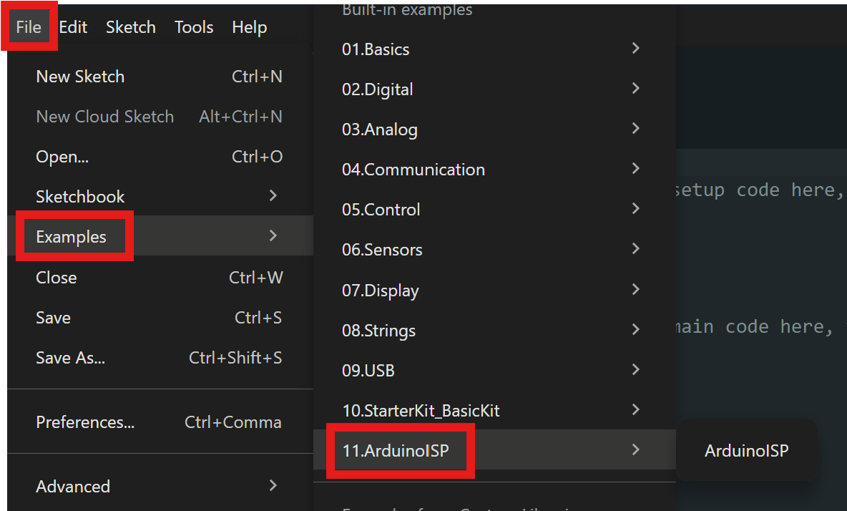

- Select the Arduino Uno (or other microcontroller) as the target board using the Select Board feature. Then click Upload (the arrow icon) to program the Uno.
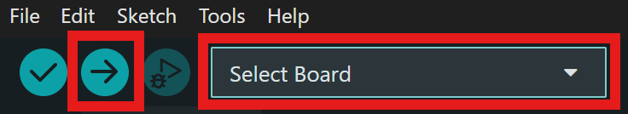
- Optionally connect an LED and 220Ω resistor in series to D7, D8, and D9. The LED connected to D7 will indicate a successful program, the LED connected to D8 will indicate if an error occurs, and the LED connected to D9 will flash a heartbeat to indicate the programmer is running.
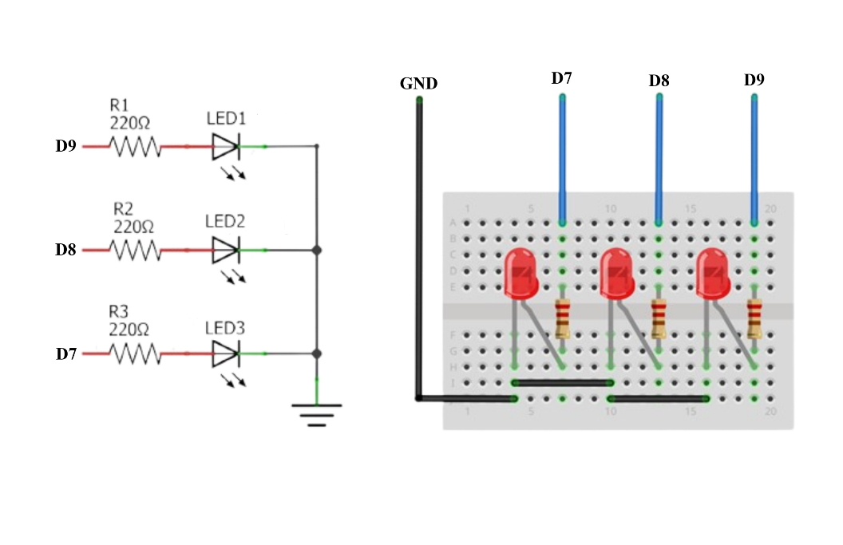
- Open the program you wish to upload to the node.
- Go to Tools ‣ Board ‣ MiniCore and select ATmega328.
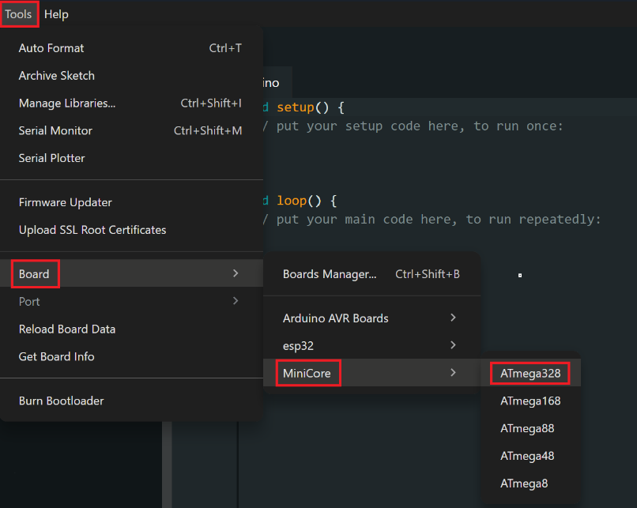
- Open Tools and change the Clock from “External 16 MHz” to “Internal 8 MHz”.
- Open Tools again and change the Variant from “328P / 328PA” to “328 / 328A”.
- Connect ICSP programmer to the node’s 02x03 Female Header as seen in the figure below. Use Male to Male Dupont connectors to make the connections.
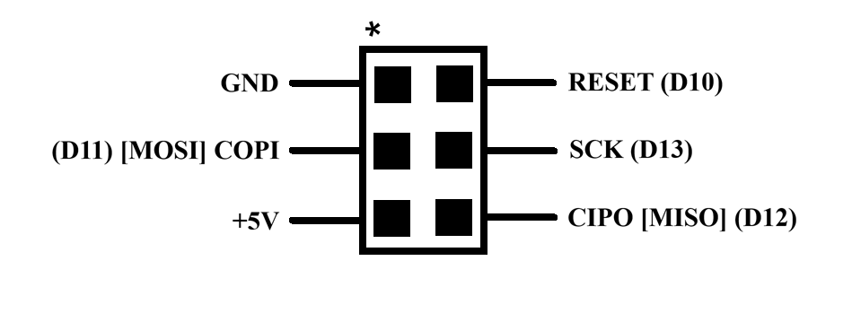
- Go to Tools and select “Burn Bootloader”. Wait for the operation to complete. If using the indicator LEDs, the LED connected to D7 should start flash during the operation and then stay solid when complete.
- Go to Sketch and select “Upload Using Programmer”. As in the previous step, the LED connected to D7 should flash and then stay solid when the operation is complete.
- You have now successfully uploaded your program!
Validation Test
To test the ICSP method above, create the below circuit. Instead of connecting your programmer to the 02x03 Female Header as seen in Step 10, make the connections in the figure.
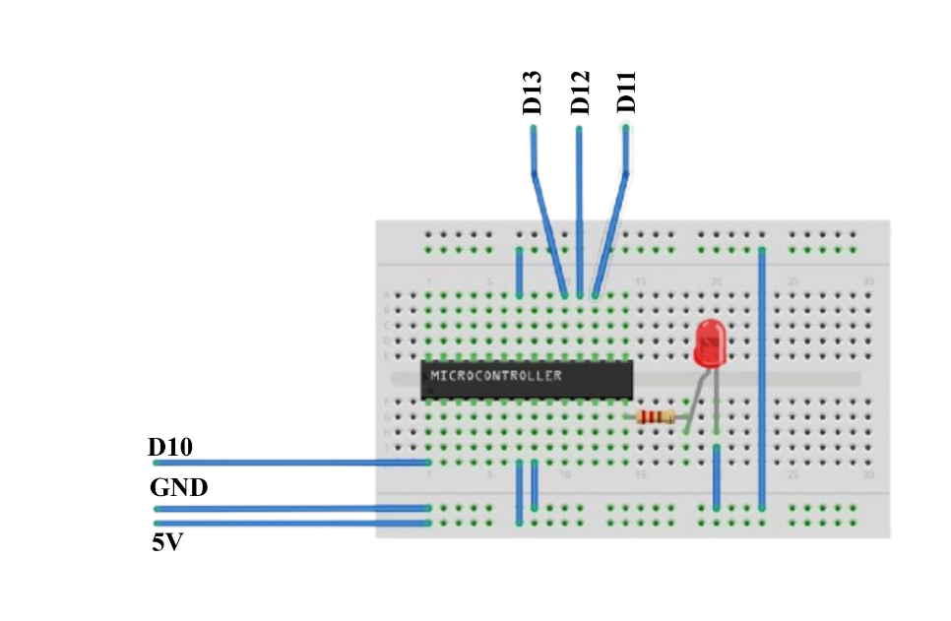
Upload the program 00_ICSP_Test.ino using the ICSP method. The LED should blink ON and OFF.

1 Soldering Instructions
Open Temperature_Node_BOM.html from the folder in any web browser to refer to as you assemble the PCB. The browser will open a webpage where you can see where to place each part on the PCB. When a component in the righthand list is hovered over, it will highlight its location on the board.

1.1 Core Microcontroller Circuit
Pre-Assembly: You will need the following components to complete this section.
- 1x 0.1uF 1206 Capacitor (C1)  - 1x ATmega328 (U1)  - 1x ATmega328 Socket  - 1x 02x03 Female Header Block (J1)  - 4x 220Ω 1206 Resistor (R8 – R11)  - 1x 10kΩ 1206 Resistor (R2)  - 1x Green LED (D1) | - 1x Orange LED (D2)  - 1x Red LED (D3)  - 1x Power LED (D4)  - 1x 01x02 Male Header Block (J2)  - 1x Jumper  - 1x Tactile Button (SW1)

Assembly:
- Start by soldering C1 to the board.
- Solder on R8-R11.
- Solder on D1-D3. Note the direction of the diodes. The cathode on D1-D3 is marked by a green dot as seen below. Orientate the part so that diode symbol on the PCB matches the one in the figure.
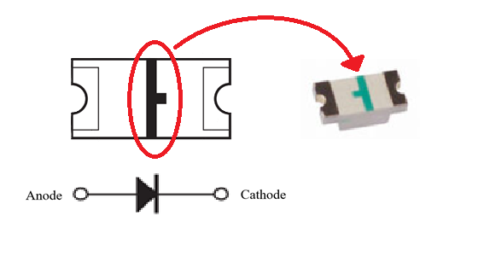
Adapted from Broadcom
- Solder on D4. The cathode is the white wire lead. Follow the same diode symbol (the arrow of the diode symbol points to the cathode) as before to properly orientation it.
- Solder on J2. After soldering it on, press the jumper onto the pins to connect them. The jumper enables the LED indicators. If removed, the LEDs will not illuminate. It is recommended to enable the LED indicators for debugging purposes, but to remove them before deployment.
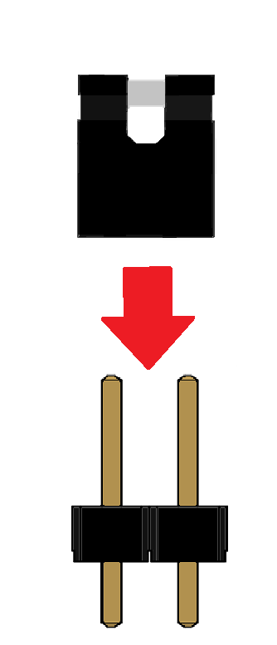
Adapted from Würth Elektronik

- Solder R2 onto the PCB. Then solder SW1.
- Solder on J1.
- Solder on U1, the ATmega328 socket. Do not directly attach the ATmega328 chip to the board.
- After soldering the socket onto the board, carefully seat the ATmega328 chip into the socket. Orientate the ATmega328 so that the side with half circle depression faces J1.
- At the end of this section, the PCB should look like the figure below.
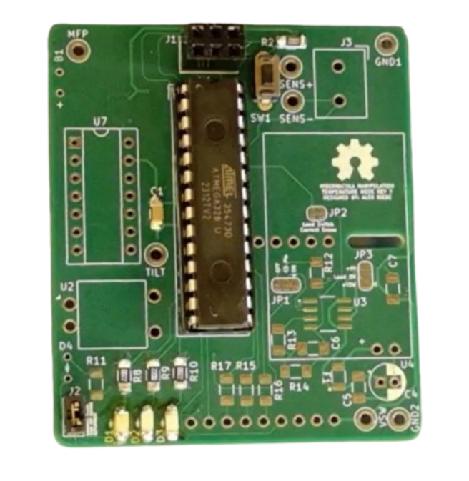

Post-Assembly Validation:
Upload 01_CoreMicro_Test.ino using the ICSP technique from Section 0.6. The indicator LEDs should all illuminate and flash in a simple sequence. View the video 01_FunctioningExample_CoreMicro.mkv to see the correct behavior. The power LED (D4) will not illuminate.

1.2 Power Circuit
Pre-Assembly: You will need the following components to complete this section.
- 1x 10nF 1206 Capacitor (C6)  - 2x 0.1uF 1206 Capacitor (C5, C7)  - 1x 10uF Electrolytic Capacitor (C4)  - 1x 150Ω 1206 Resistor (R13)  - 1x 1kΩ 1206 Resistor (R14) | - 1x Load Switch (U3)  - 1x LiPo Booster/Charger  - 1x LiPo Battery  - 1x 350mA Polyfuse (F1)  - 1x 01x02 Female Header Block
In addition, these optional components can simplify debugging and validation.:
- 1x Orange Test Point (VSW)
- 2x Black Test Point (GND1, GND2)
A simple 3D printed support can strengthen the connection of the LiPo Booster Charger. The .stl for this part can be found in the files for this project.

Assembly:
- Solder on C6. Follow this by soldering on R13 and then R14.
- Solder F1 onto the PCB. Then solder on the line filtering capacitor C5.
- Solder on U3 and then C7.
- Solder on the female header pins to U4. Do not directly attach the LiPo Booster/Charger to the PCB.
- Solder on the bulk capacitor C6. Clip the excess leads with a flush cutter.
- At this point, if you would like to simplify validation solder on the VSW test point and at least one of GND test points. It is recommended to do this at least on the first board you manufacture.
- The PCB should now look like the figure below.
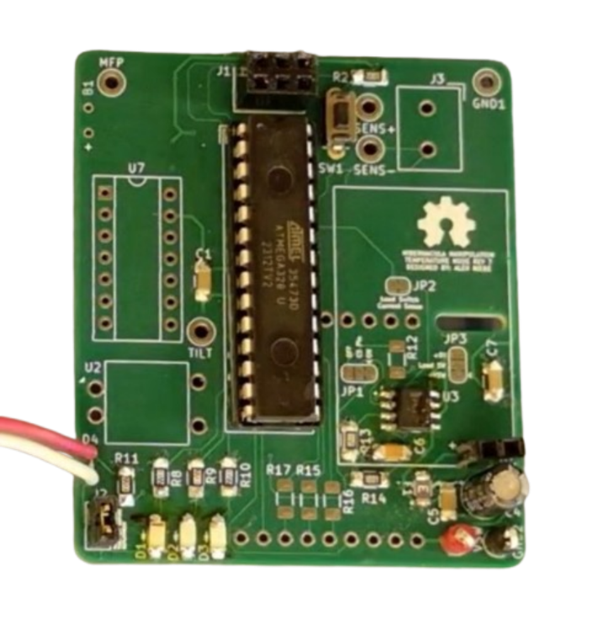
- Assemble the LiPo Booster/Charger by attaching two header pins to Output Pins as seen below. Do not attach to all other through hole connections.
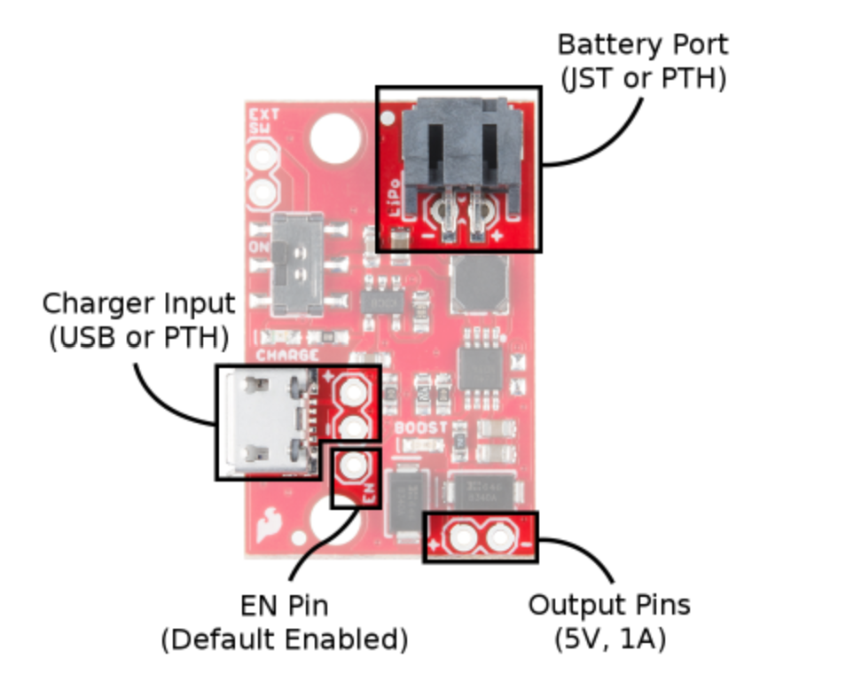 | 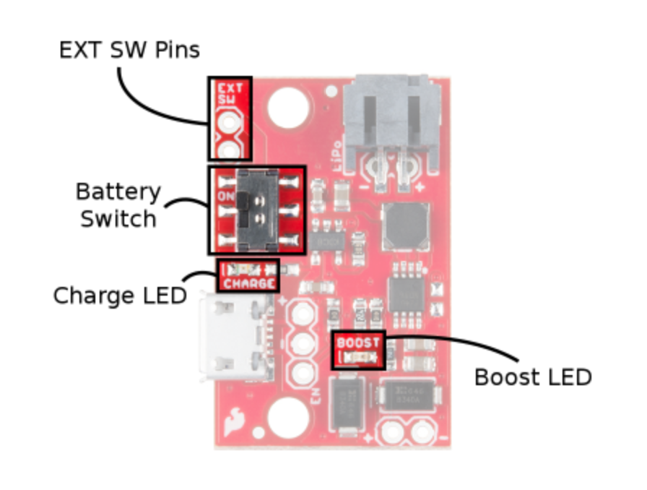
From SparkFun

- Plug in the battery into the JST Battery Port pictured above.
- Push the LiPo Booster/Charger onto the header pins. The Battery Switch acts as the ON/OFF switch for the PCB. When the Boost LED illuminates red, the LiPo Booster/Charger is providing power to the device. The LiPo battery can be charged by connecting a micro-B Charger input to power. The Charge LED should illuminate blue.
- If you 3D printed the optional support, turn off and remove the LiPo Booster/Charger from the board. Hot glue the support onto the corner opposite of the header pins on the bottom of LiPo Booster/Charger. Then place it back onto the header pins.
- At this point, the PCB should look like the figure below.
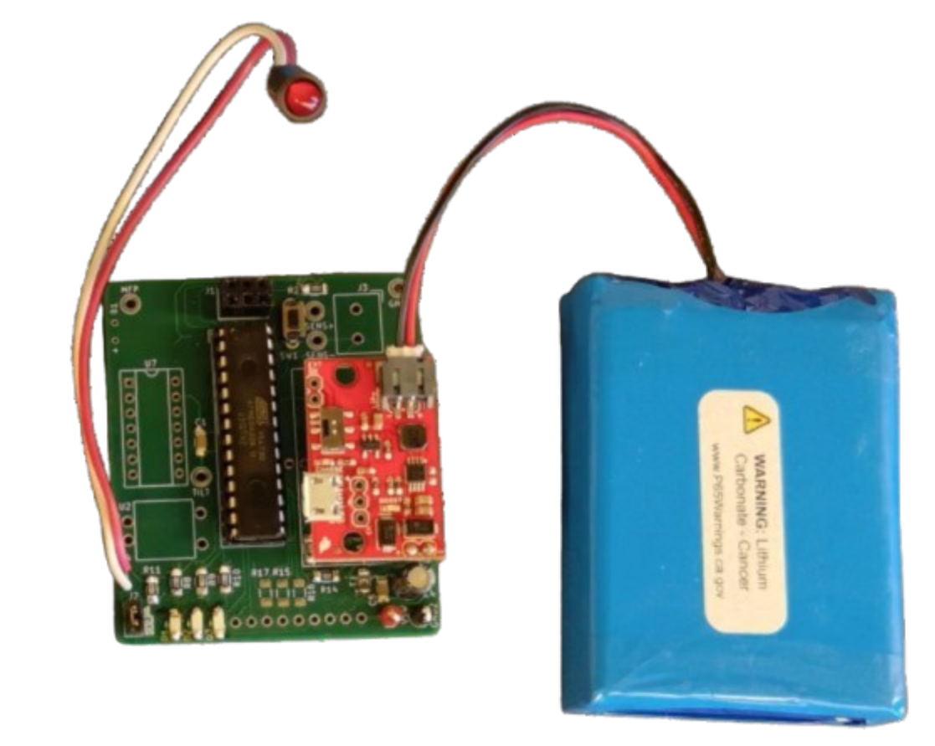

Post-Assembly Validation:
Check to make sure the LiPo Booster/Charger is turned ON (the Booster LED should be illuminated). Check the DC voltage between the 5V line and GND with a multimeter (if you are unfamiliar with using multimeters, click here) to validate that power is being provided to the board. The easiest place to probe for 5V is the pin of SW1 that is closest to the edge of the board. Either of the two GND test points will work for ground. If ±0.1V of 5V is seen, the LiPo Booster/Charger is properly providing power.
To test the load switch and power saving features, upload the 02_PowerCircuit_Test.ino using ICSP. This program tests the load switches capabilities to turn off nonessential circuitry during deep sleep. The orange LED should remain ON for the duration of the program, but the Power LED should turn ON and OFF. View the video 02_FunctioningExample_PowerCircuit.mkv to see correct behavior. As the program runs, measure the voltage between VSW and GND. It should oscillate between 5V and 0V at the same frequency as the LED flashes.

1.3 Real Time Clock (RTC) Circuit
Pre-Assembly: You will need the following components to complete this section.
- 2x 0.1uF 1206 Capacitor (C11, C12)  - 1x 4.7uF 1206 Capacitor (C2)  - 1x 10kΩ 1206 Resistor (R1)  - 1x Real Time Clock (U8) | - 1x Temperature Controlled Oscillator (U7)  - 2x Coin Battery  - 1x Coin Battery Case (B1)
In addition, these optional components can simplify debugging:
- 2x 4.7kΩ 1206 Resistor (R3, R4)
- 1x Orange Test Point (MFP)

Assembly:
- Remove the LiPo Booster/Charger from the header pins.
- Solder on C2, then the pull up resistor R1.
- Solder C11 onto the PCB.
- Solder on U8. Orientate the component so that the IC’s polarity mark (a dot on the component to indicate pin 1) is aligned to the orientation indicator on the silkscreen, like the figure below shows.
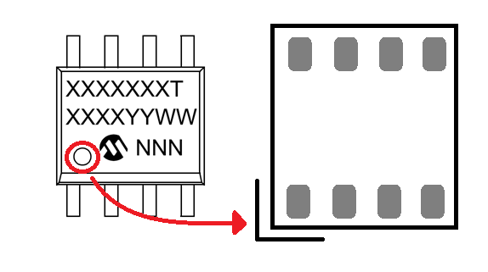
Adapted from Microchip Technology
- Solder on the decoupling capacitor C12. At this point, the back of the PCB should look like this.

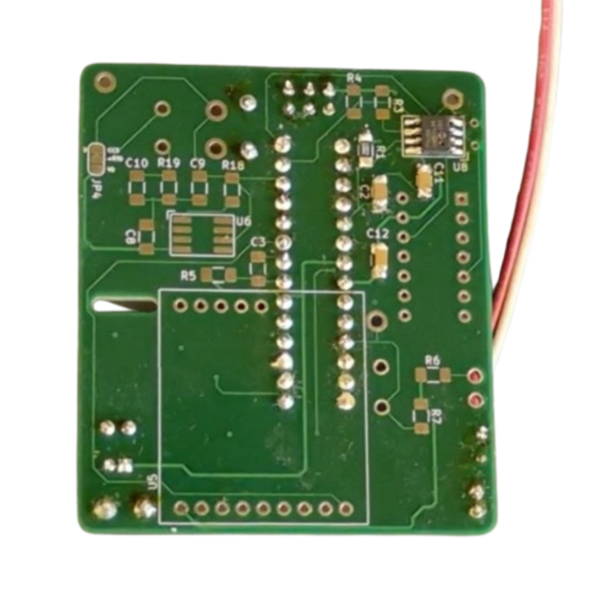
- Solder U7 onto the PCB. Orientate it the same as previous component, aligning the dot to the silkscreen mark.
- Strip the wire leads on the battery case. The solder it onto B1 on the PCB. Note the polarity of the leads as seen in the figure below.
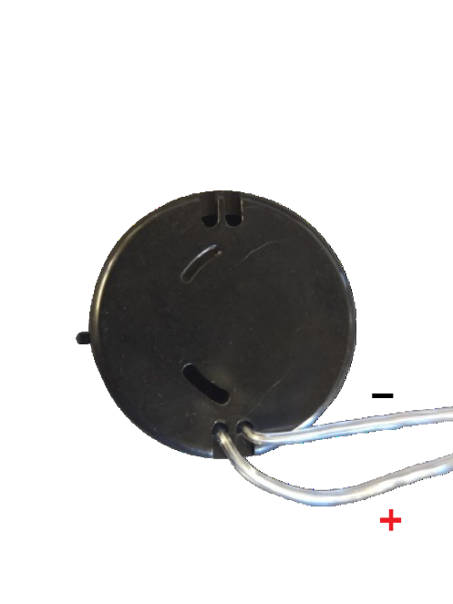
- It is recommended to hot glue the battery leads where they meet the PCB to increase the robustness of the joint. If this is not done, the leads will often snap. Zip tie the battery leads for wire management.

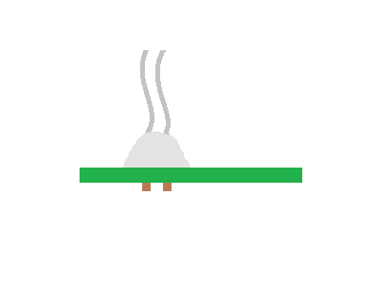

- Add both the coin batteries to the case. Orientate the coin batteries so the positive side (marked with a +) is facing upwards, out of the case.
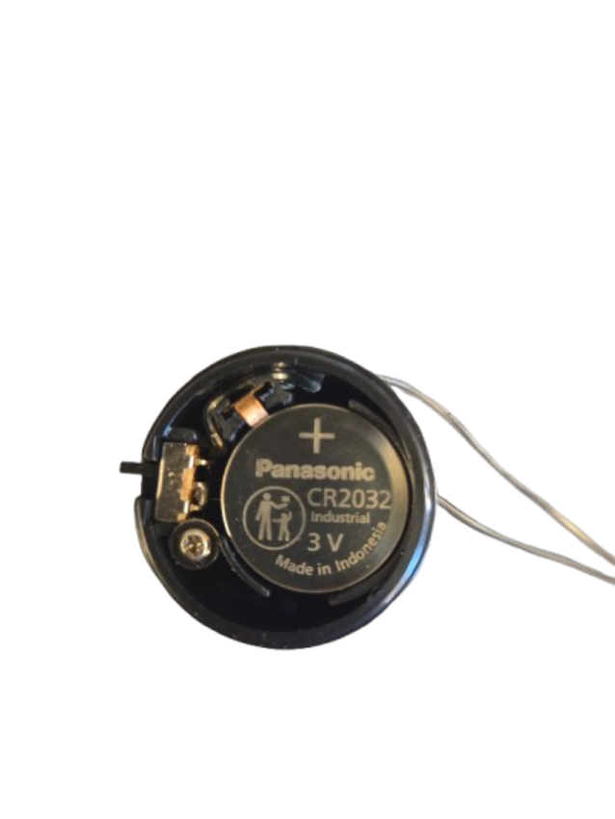
- Optionally, solder the MFP test point for easier debugging.
- At this point the front of the PCB should look like the figure below.
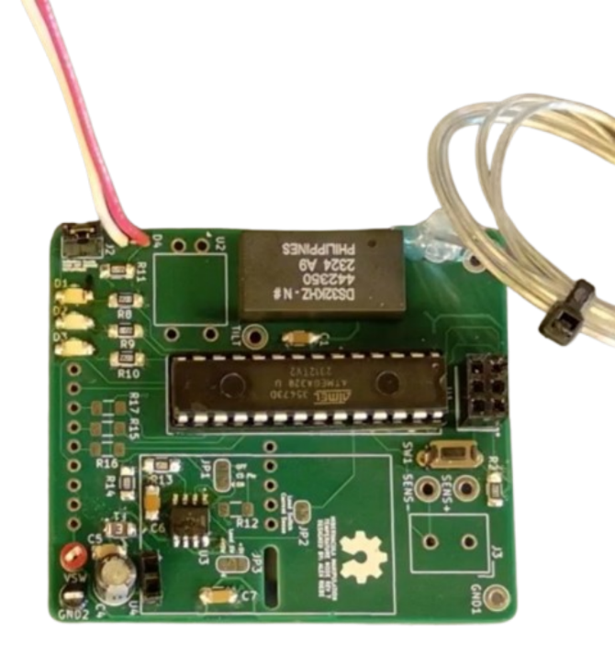

Post-Assembly Validation:
Push the LiPo Booster/Charger back onto the header pins. Upload the program 03_RTCBaseFunctionality_Test.ino using the ICSP. The orange indicator LED should blink ON and OFF. View the video 03_FunctioningExample_RTCBaseFunctionality.mkv for correct behavior. This tests the time keeping ability of the RTC circuit and confirms that the I2C communication and oscillator is working. If this step does not work, you may need to add the resistors R3 and R4 to the board for more reliable pullups.
Next upload 03_RTCAlarm_Test.ino to PCB. For this test the green LED should blink, but at a slower rate than the orange LED from the base functionality test. View the video 03_FunctioningExample_RTCAlarm.mkv for correct behavior. This tests the RTC circuit alarm functionality which is used to wake the temperature node from deep sleep at the correct time to communicate back to the base station.

1.4 Temperature Measurement Circuit
Pre-Assembly: You will need the following components to complete this section.
- 4x 0.1uF 1206 Capacitor (C3, C8, C9, C10)  - 1x 34Ω 1206 Resistor (R18)  - 1x 1kΩ 1206 Resistors (R19) | - 1x Constant Current Source (U6)  - 1x 01x02 Screw Terminal (J3)
In addition, these optional components can simplify debugging:
- 2x Orange Test Point (SENS+, SENS-)

Assembly:
- Solder on C10. Then R19, followed by C9 and R18.
- Solder C3 onto the PCB.
- Solder on U6. The first pin is indicated in the same way as before on the PCB’s silkscreen. The first pin on the constant current source is indicated by lettering as seen in the figure below.
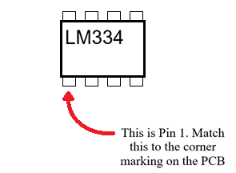
- Solder on C8. The back of the PCB should look like this.
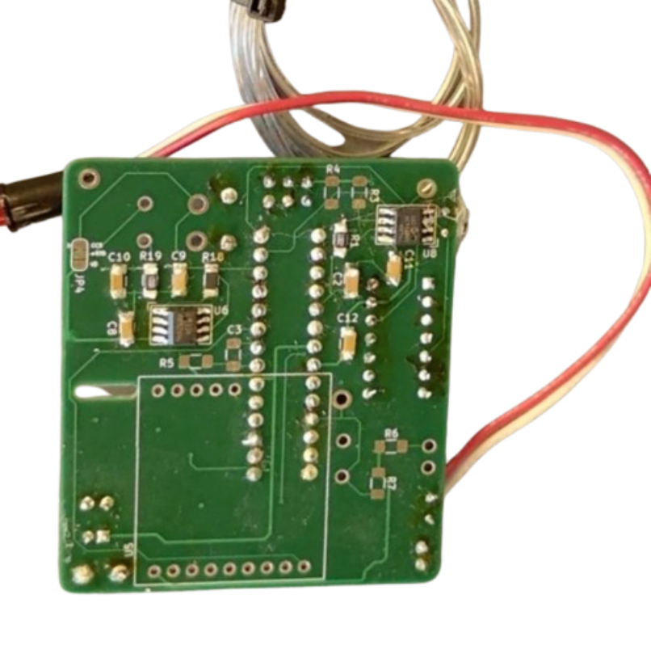
- Solder on J3. Orientate the screw terminal so that the inputs are facing towards the outside edge of the PCB, away from the ATmega328. The screw terminal is a larger component than the other components so it may take longer and require more solder to achieve a quality joint.
- Optionally add the test points SENS+ and SENS- for easier debugging.
- At this point, the PCB should look like the figure below.
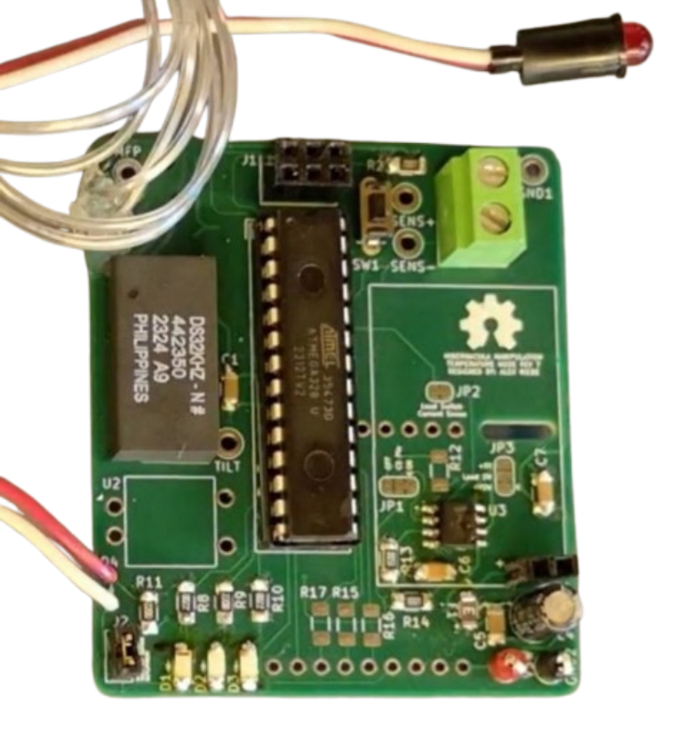

Post-Assembly Validation:
Connect pins 1 and 2 of a 1kΩ potentiometer to the screw terminal inputs. Pin 2 is the middle pin of the potentiometer. Either of the two outside pins can function as pin 1. Orientation does not matter for which pin goes to which screw terminal input.
Once the hardware is set up, upload 04_TempMeasurements_Test.ino using ICSP. After uploading, spin the potentiometer up and down to mimic temperature fluctuations. The green LED should change brightness as the potentiometer is spun. For the correct behavior view the video 04_FunctioningExample_TempMeasurements.mkv.

1.5 Radio Module
Pre-Assembly: You will need the following components to complete this section.
- 3x 220Ω 1206 Resistor (R15, R16, R17)  - 1x RFM69HW Module (U5)  - uFL SMT Antenna Connector | - SMA to uFL Adapter Cable  - 915 MHz Whip Antenna

Assembly:
- Solder series resistors R15-R17 onto the PCB. The front of the PCB should look like this.
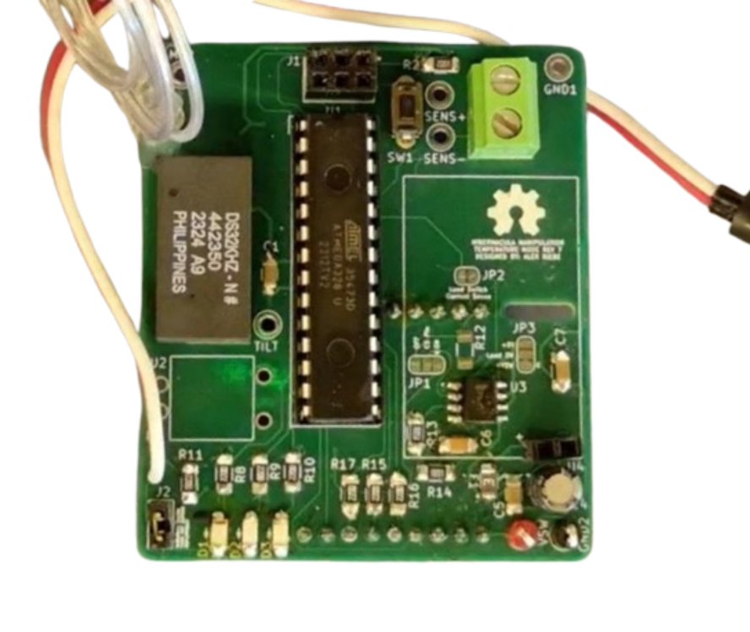
- Follow along with this guide from AdaFruit to assemble the RFM69HW module by attaching the header pins and uFL SMT Antenna Connector. For the Antenna Options section, follow the uFL connector option. The Wire Antenna and SMA Edge-Mount Connector sections can be ignored.
- Press the RFM69HW module onto U5 on the back of the board and solder it onto the board. At this point the back of the PCB should look like this.
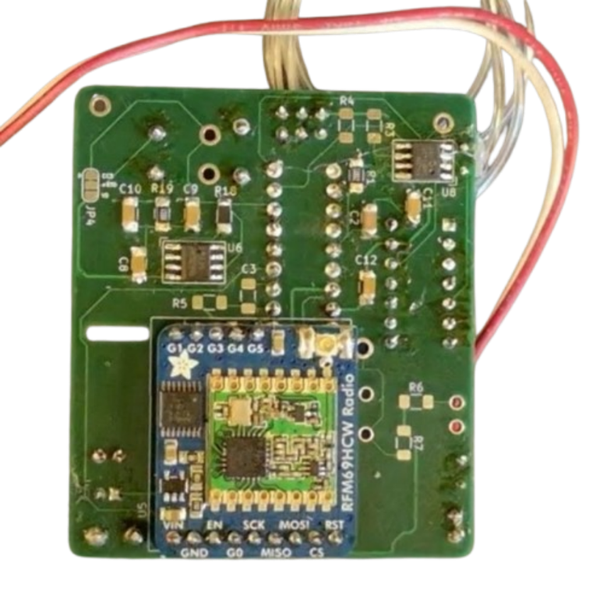
- Screw whip antenna onto the SMA side of the SMA to uFL adaptor cable.
- Press the other end of the cable onto uFL connector on the RFM69HW module

Post-Assembly Validation:
Upload the program 05_Radio_Test.ino using ICSP. This test communication between the radio and ATmega328. It will attempt to transmit a message, but if you do not have a base station assembled and working it will fail. After uploading the orange and red LED should illuminate, indicating that both halves of the initialization process have succeeded. The green LED should flash ON and OFF, indicating when a message is sent.

1.6 Miscellaneous Components
Pre-Assembly: This section is optional but will allow the device to indicate it’s in the field. This can be important if the antenna linkages are fragile and a specific orientation are critical or if the device is in a hazardous environment such as a partial water filled cave. You will need the following components to complete this section.
- 1x 150Ω 1206 Resistor (R6)  - 1x 100kΩ 1206 Resistor (R7) | - 1x Tilt Switch (U2)
In addition, these optional components can simplify debugging:
- 1x Orange Test Point (TILT)

Assembly:
- Solder R6 and R7 onto the PCB.
- Solder U2 onto the board.
- Optionally, solder the test point TILT onto the PCB.
- At the end of this step, the PCB should look like the figure below.

